Project Planning Phase
Project Planning Template (Product Backlog, Sprint Planning, Stories, Story points)

Date | 15-07-2026
Team ID | SWTID-2026-3345
Project Name | BookVerse – Online Book Store
Maximum Marks | 5 Marks

Product Backlog, Sprint Schedule, and Estimation (4 Marks)
Use the below template to create product backlog and sprint schedule
Sprint | Functional Requirement (Epic) | User Story Number | User Story / Task | Story Points | Priority | Team Members
Sprint 1 – Core Development | User Mgmt & Auth | USN-1 | As a user, I can register for the application by entering my email and password. | 2 | High | Parandama Boorsu
Sprint 1 – Core Development | User Mgmt & Auth | USN-2 | As a user, I can log into the application by entering my email and password. | 1 | High | Parandama Boorsu
Sprint 1 – Core Development | Search & Filters | USN-3 | As a user, I can search for books by title or author and filter by categories (Biographies/Fiction/Science). | 2 | High | Abhishek Kalluru
Sprint 2 – Marketplace Features | Cart & Checkout | USN-4 | As a user, I can add multiple books to a cart and check out in a consolidated multi-vendor order. | 3 | High | Boodi Puneeth Reddy
Sprint 2 – Marketplace Features | Cart & Checkout | USN-5 | As a user, I can track each item in my order with a status timeline. | 2 | High | Boodi Puneeth Reddy
Sprint 2 – Marketplace Features | Inventory Mgmt | USN-6 | As a seller, I can manage my books inventory and see low stock warnings. | 2 | Medium | Abhishek Kalluru
Sprint 2 – Marketplace Features | Fulfillment Ops | USN-7 | As a seller, I can accept orders, update delivery status, and view total sales stats. | 3 | High | Boodi Puneeth Reddy
Sprint 3 – Deployment & Testing | Seller Control | USN-8 | As an admin, I can view, approve, and block registered sellers. | 2 | Medium | Parandama Boorsu
Sprint 3 – Deployment & Testing | Dynamic Stats | USN-9 | As an admin, I can view counters of available books, registered sellers, and registered users. | 2 | Medium | Abhishek Kalluru

Project Tracker, Velocity & Burndown Chart: (4 Marks)
Sprint | Total Story Points | Duration | Sprint Start Date | Sprint End Date (Planned) | Story Points Completed (as on Planned End Date) | Sprint Release Date (Actual)
Sprint 1 – Core Development | 5 | 3 Days | 09-07-2026 | 11-07-2026 | 5 | 11-07-2026
Sprint 2 – Marketplace Features | 10 | 2 Days | 12-07-2026 | 13-07-2026 | 10 | 13-07-2026
Sprint 3 – Deployment & Testing | 4 | 2 Days | 14-07-2026 | 15-07-2026 | 4 | 15-07-2026
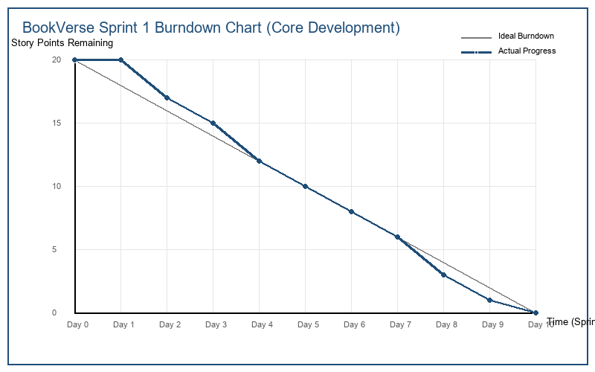
Velocity:
Imagine we have a 10-day sprint duration, and the velocity of the team is 20 (points per sprint). Let’s calculate the team’s average velocity (AV) per iteration unit (story points per day)


Burndown Chart:
A burn down chart is a graphical representation of work left to do versus time. It is often used in agile software development methodologies such as Scrum. However, burn down charts can be applied to any project containing measurable progress over time.

https://www.visual-paradigm.com/scrum/scrum-burndown-chart/
https://www.atlassian.com/agile/tutorials/burndown-charts

Reference:
https://www.atlassian.com/agile/project-management
https://www.atlassian.com/agile/tutorials/how-to-do-scrum-with-jira-software
https://www.atlassian.com/agile/tutorials/epics
https://www.atlassian.com/agile/tutorials/sprints
https://www.atlassian.com/agile/project-management/estimation
https://www.atlassian.com/agile/tutorials/burndown-charts

Figure 4.1: BookVerse Sprint 1 Burndown Chart

